ATOC 3500/CHEM 3151 Spring 2018
Problem 19
A Simple Approximation of a Calculation of a Photolysis Rate
The NO₂ Molecule

The figures below show the absorption cross section (σ_{λ}) for nitrogen dioxide (NO2)
and the solar radiation spectrum or solar flux (I_{λ}) , where yellow represents measurements from space and red represents the solar spectrum at Earth's surface. The difference between yellow and red curves is the solar radiation that is absorbed by Earth’s atmosphere. The red and blue boxes are estimates of average values for σ_{λ} and I_{λ} over the spectral range 300-550 nm (you can find more details in the lectures notes). The photolysis rate, J, is defined as the integral over all wavelengths of the product of these two quantities and the quantum yield.

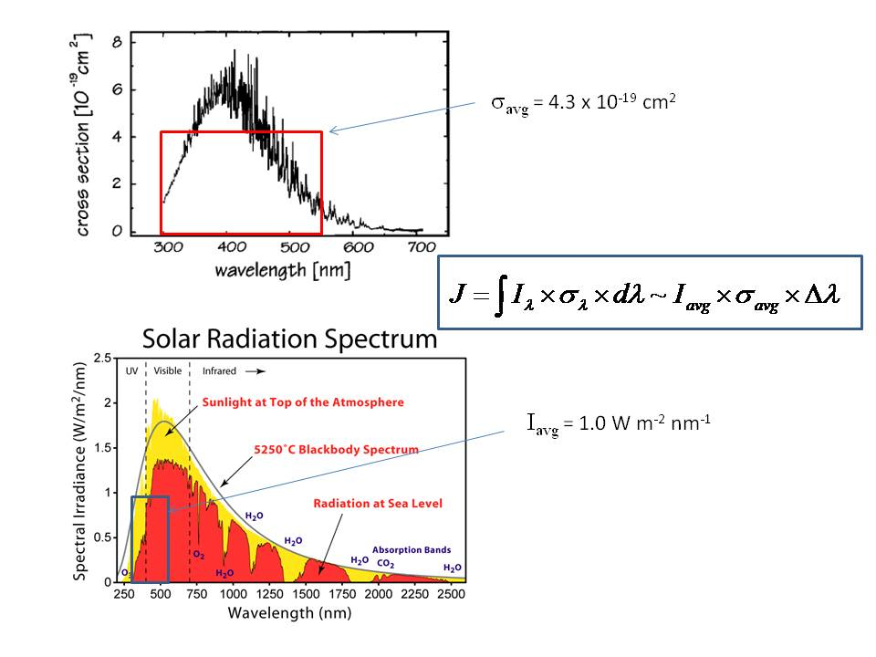
(a) Calculate the photolysis rate of NO₂ at Earth's surface in units of s⁻¹. Assume the quantum
yield for photolysis is unity (i.e., = 1) over the full wavelength range. Use the average values over the range 300-550 nm, and the equation in the box that is in the figure. Remember to convert from units of Watts to photons, using the method you applied in Problem 8. You can assume that the average photon has a wavelength of 425 nm, so the energy per photon is 4.68 x 10⁻¹⁹ Joule. Note that 1 W = 1 Joule per second.

(b) Using the result from Part (a), what is the lifetime of NO₂ relative to photolysis at Earth's surface?

(c) If for Part (a), instead of using the solar radiation spectrum at sea level (red) you had used the spectrum at the top of the atmosphere (yellow), how much larger do you think your answer would have been? Note that this calculation would have given you the photolysis rate (J value) for NO₂ high up in the stratosphere, above any atmospheric absorbers.

(d) The spectrum below is for ozone (O₃). Describe qualitatively why the photolysis rate of ozone is much smaller than the photolysis for NO₂ at Earth's surface.

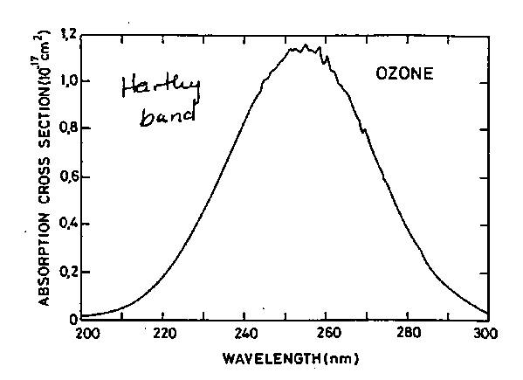

(e) Based on the solar spectrum in Part (a), in order for a molecule to photolyze in the lower atmosphere (e.g., Earth's surface), it must have an appreciable absorption cross section at wavelengths longer than what threshold?

