ATOC 3500/CHEM 3151 Spring 2018
Problem 16
Stratospheric Ozone Destruction in the “Ozone Hole”
In Problem 15 we saw how to calculate the steady state ozone concentration when there are catalytic cycles that increase the rate of ozone loss. The ozone hole is a very different situation, whereby ozone is not in steady state because there isn’t enough ultraviolet light to photolyze O₂ and produce odd oxygen. In this case, loss processes simply ‘chew away’ at the ozone, eventually destroying all of it in about a month.

The figure below shows typical observations of the total amount of ozone in a layer of air 8 km thick between 12 and 20 km over the South Pole (recall that we like to express the ‘thickness of ozone’ of this layer in Dobson Units, because of the use of a particular kind of instrument that measures the amount of sunlight in the ultraviolet – the more ozone there is between the instrument and the sun, the larger the “ozone column”). Note that in 1967-1971 (black dots), very little ozone destruction was observed, whereas 20 years later, significant ozone losses were observed (and this has been the case every year since 1986).*

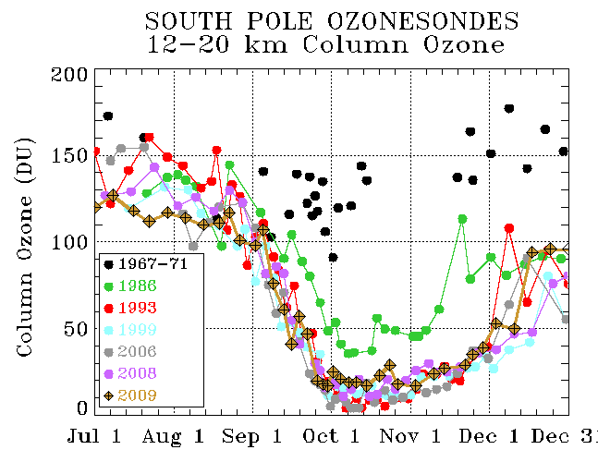

- Estimate the average rate of change of ozone (d[O₃]/dt) in units of molecules cm⁻³ s⁻¹ for the time period Sept. 1 to Oct. 1. Assume that in this layer, 1 DU = 0.03 parts per million of ozone, and use an average P = 70 mbar and T = 195 K between 12 and 20 km to convert from parts per million into a concentration.

- It is believed that the reaction ClO + ClO + M ClOOCl + M is the main way that ozone is destroyed over Antarctica in Springtime. Each time this reaction occurs, two ozone molecules are ultimately destroyed. Therefore, we can write the following expression for the time rate of change of ozone:

d[O₃]/dt = – 2 k^{III} [ClO]²[M]

Using the value for M from Part (a), and the expression k^{III} = 5.5 x10⁻³² cm⁶ molecule⁻² s⁻¹, calculate the concentration of ClO that would be necessary to explain the rate of change of ozone that you estimated in Part (a) from the data shown in the figure.

- Convert the concentration of ClO in Part (c) to a mixing ratio in parts per billion (ppb). Compare your result to the ClO mixing ratio that was observed by an aircraft flying over Antarctica in mid-September 1987 (you should be able to find a value in a figure in the textbook).

*The ‘gap’ between 1971 and 1986 was due to the fact that it is very expensive and difficult to carry out these measurements, and since it didn’t seem like much was happening back in 1971, such measurements weren’t carried out again until 1986 when the ozone hole was discovered. There were measurements from the ground, however. So we know that the ozone hole wasn’t there before 1980 (going back to the 1950s when the first observations were obtained) and that it has been there every year since 1980.

